1. Set up a web app (Central US):

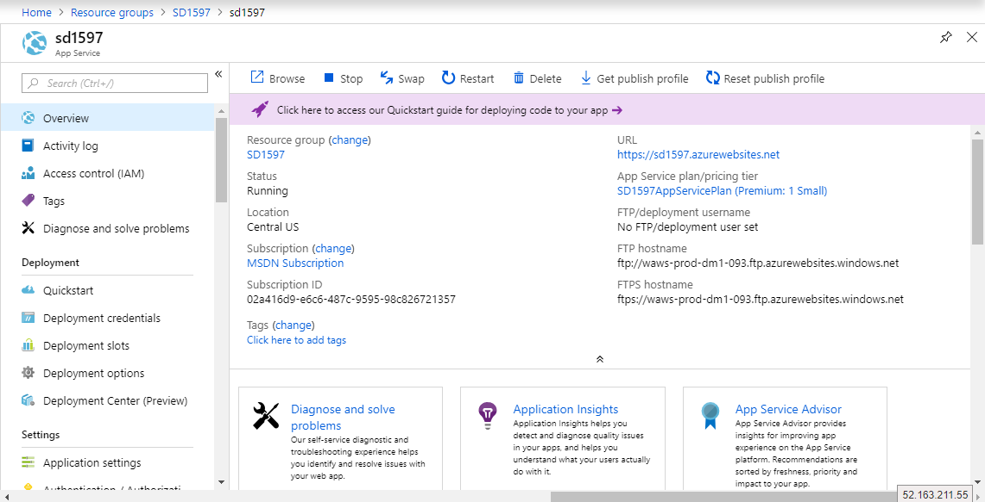

1. Set up 2 additional deployment slots:

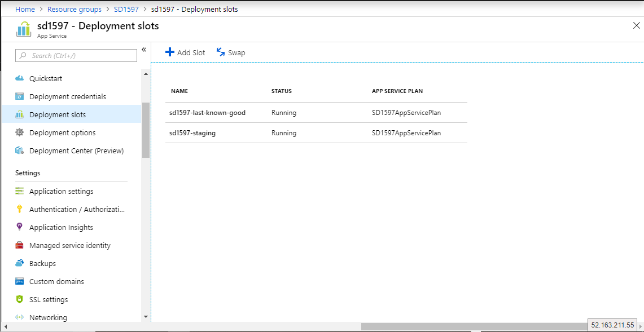

1. Set up another web app (East Asia):

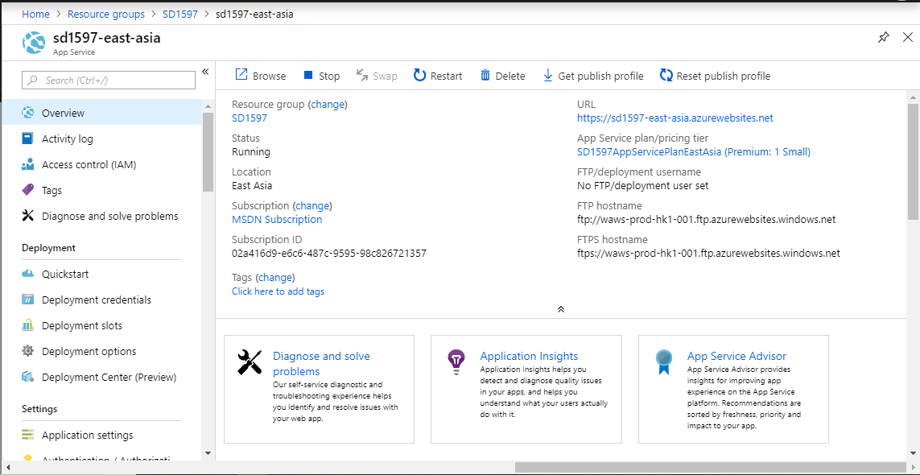

1. Set up traffic manager:

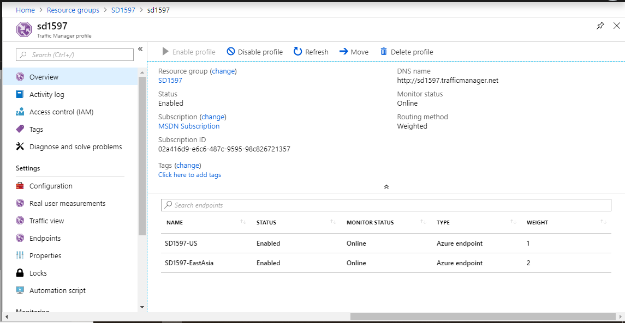

* Create 2 enpoints:

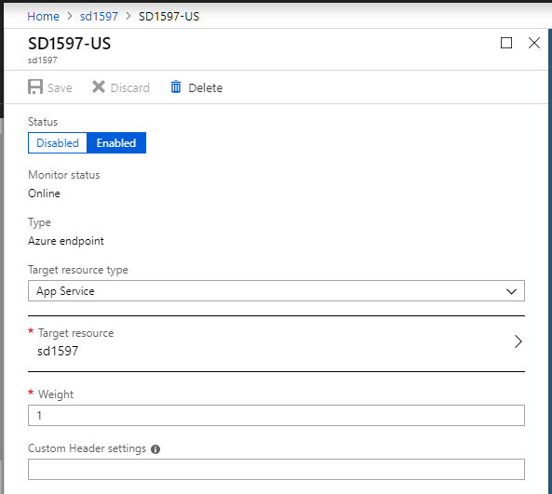

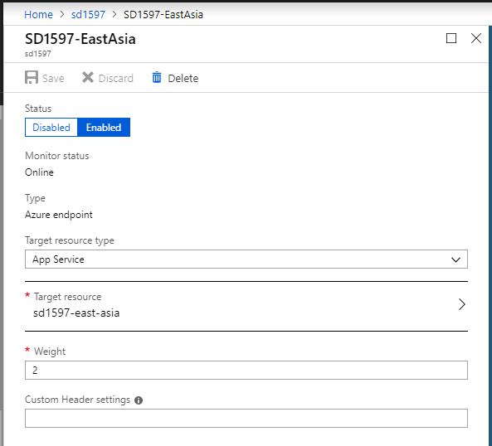

1. Set up a new SQL database (East US):

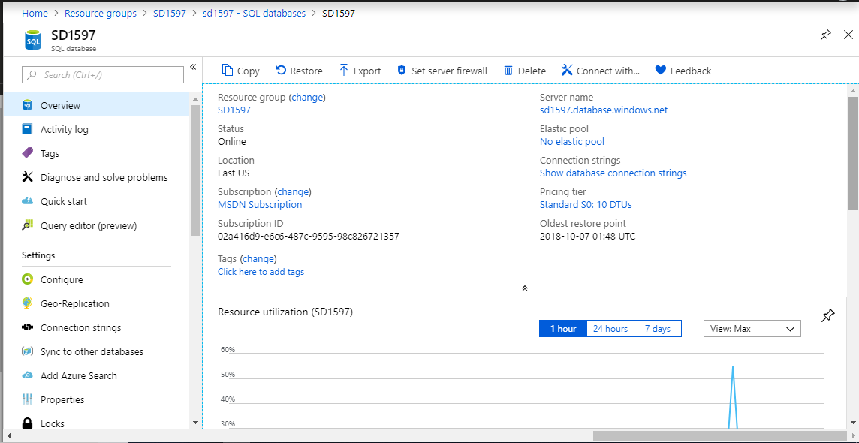

1. Set up Geo-Replication (Southeast Asia)

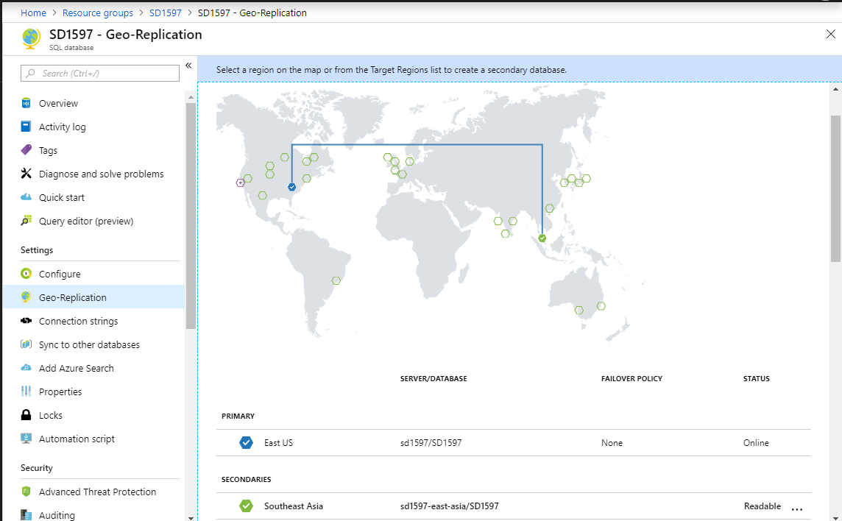

* Verify using SSMS:

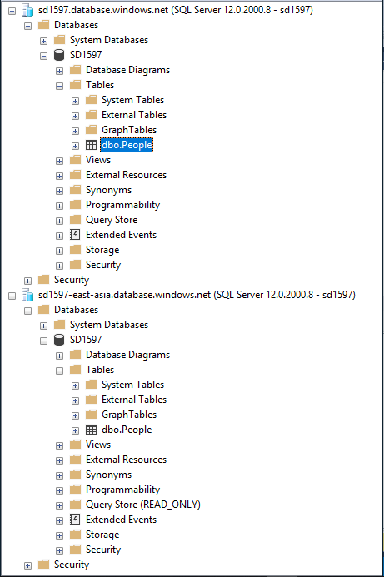

1. Set up Failover group:

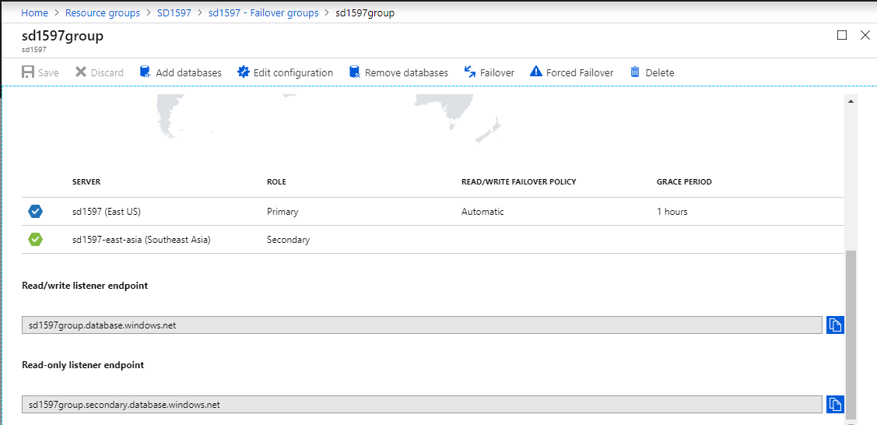

* Verify:

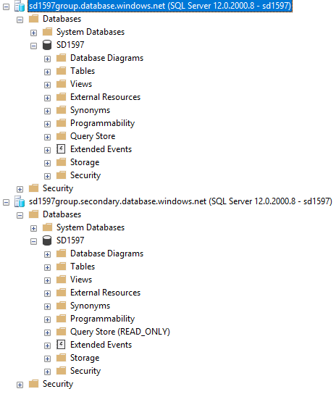

1. Set up Redis Cache:

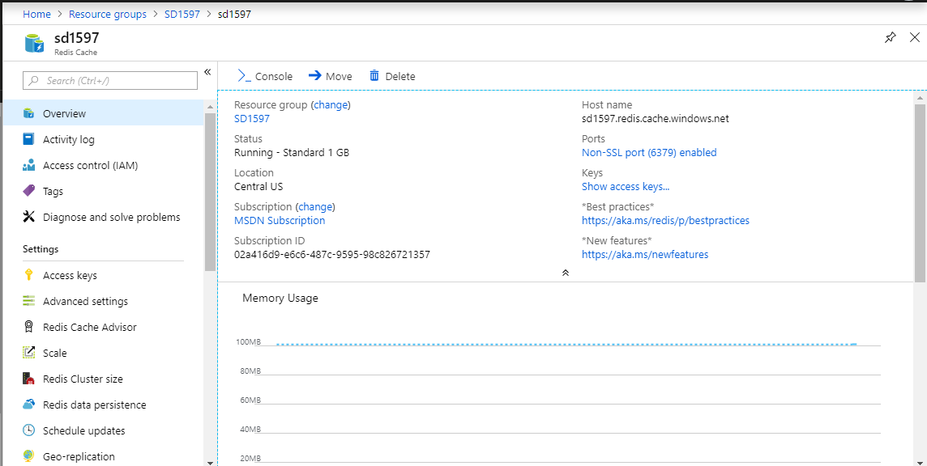

* Verify using redis-cli.exe:

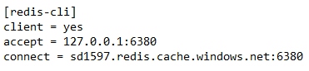

redis-cli.exe -p 6380 -a FO3zblBqz+N54ObWeP9Xhz9nbveHaheZAH5n71qqXQw=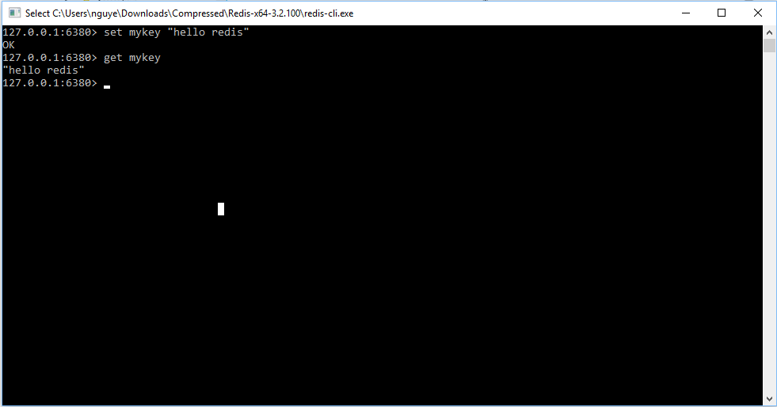

1. Set up Blob storage with CDN

* Set up storage account

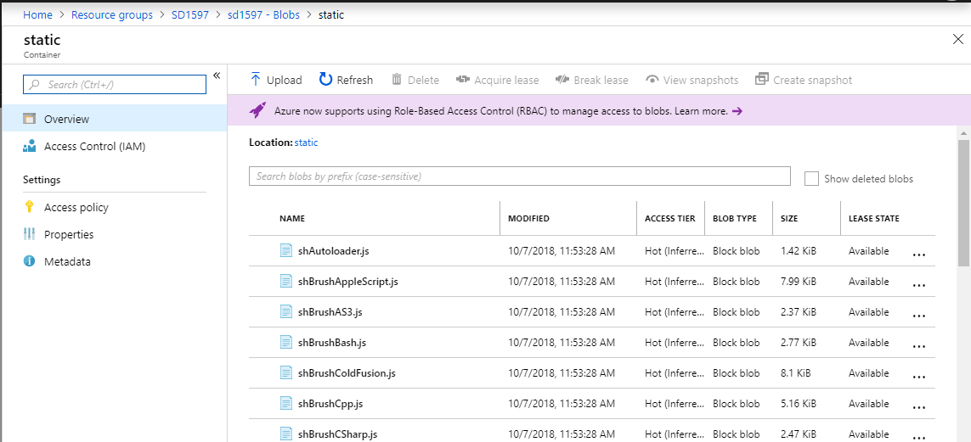

* Set up CDN Profile:

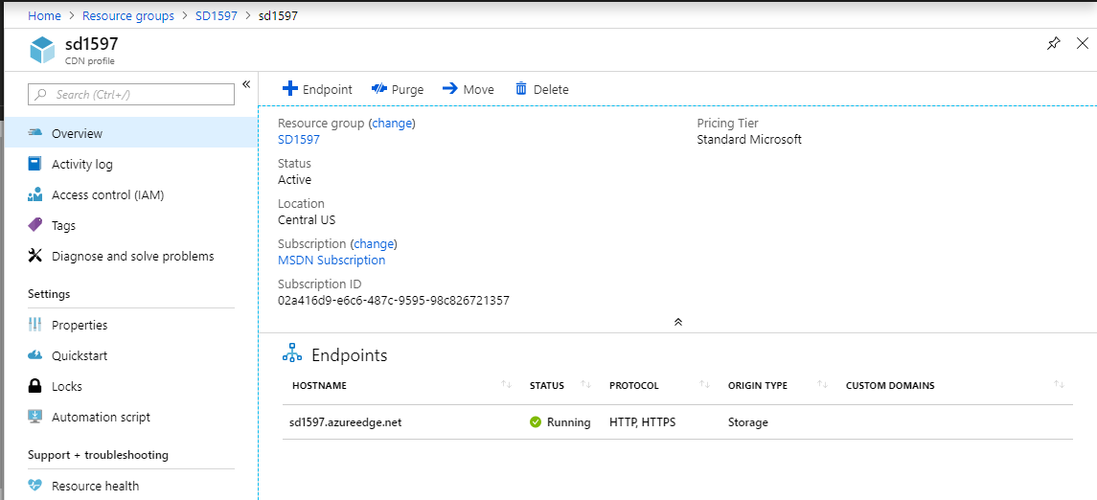

* Create enpoint:

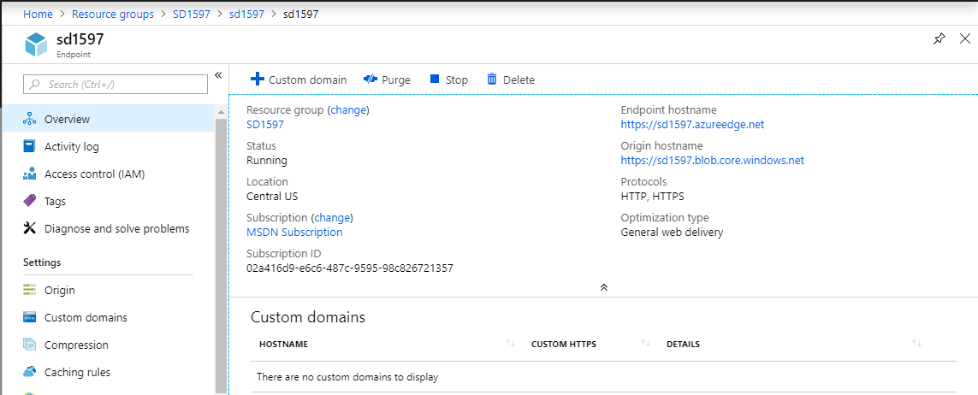

* Verify:

